**Personal Portfolio**

**For Matthew Pike**

Group 19

N9746609

Github: https://github.com/mahdsckilz/Inner-City-Hackers

**Artefact 1** – Displaying POI information for each object

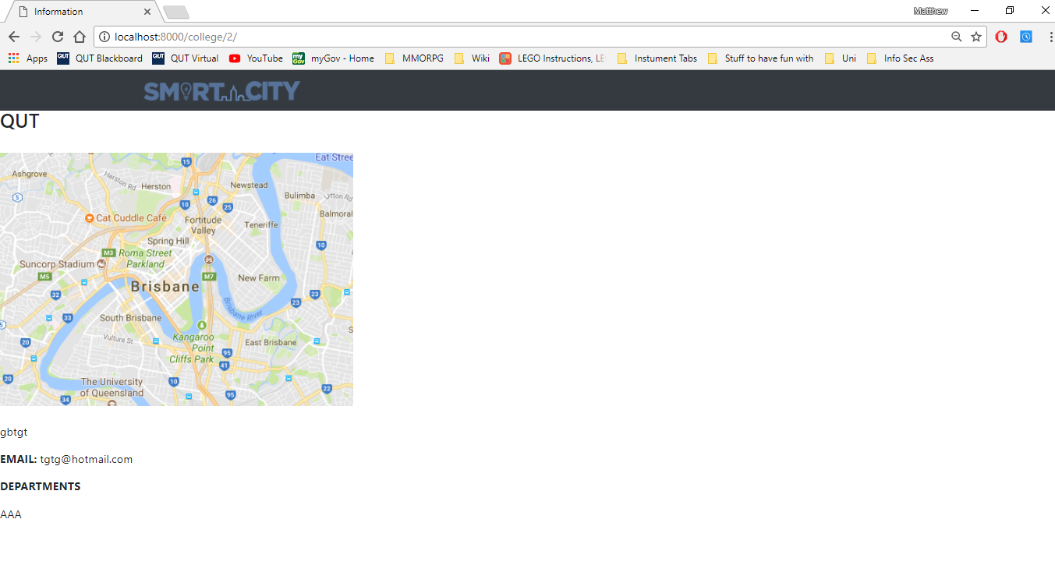

I implemented a webpage so that when one of the POI’s where selected, it would load a webpage that displayed a map of the area and any of the relevant information for that POI.

File path on github: template/inventory/item_detail.html

Relevant user story: S01-S07

**Artefact 2** – User flow of web application

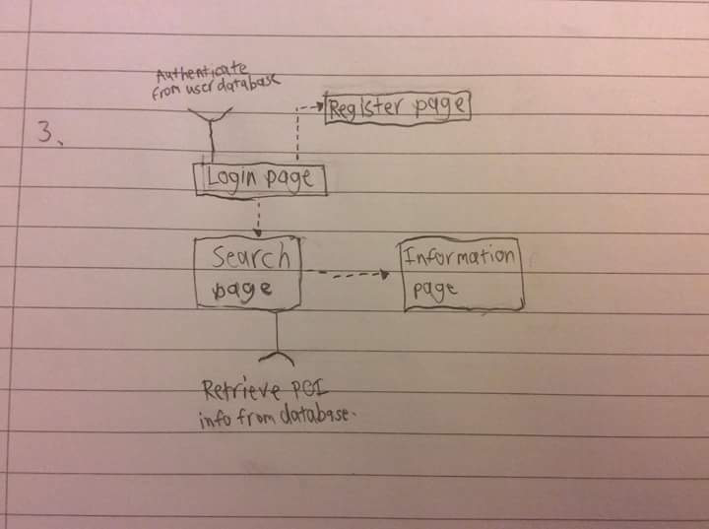

As part of the tutorial homework, I designed a workflow diagram for our web application. This was used by the design team and the programmers to create the app so that it flowed well from one page to the next.

Pictured above and found on github.

**Artefact 3** – Sprint and Release plan document

Together as a team, we all contributed to the story ideas and sprint and release plans. We used these to keep us on track with where the assignment was meant to be at points along the way to the submission date.

The file can be found on github.

**Artefact 4** – Testing and verification of application

Together as a team, we worked though the testing of and verifying that the application worked as it was meant to.

The file can be found on github.